Creating a Facebook Page
To create a Facebook Page you will already need a Facebook account.
If you’re using a computer you should see Pages on the left hand-side, you may need to select see more.
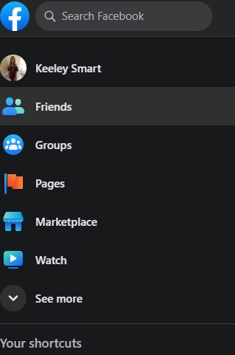
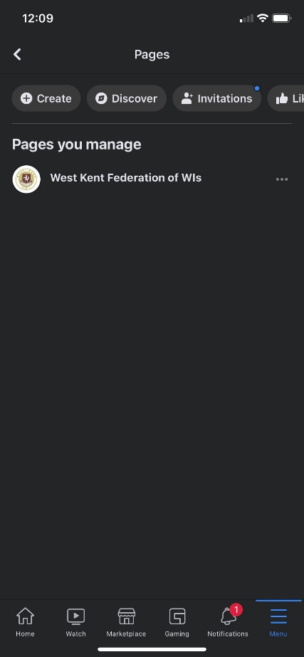
Alternatively, if you’re using a Mobile Phone, or a Tablet, you will need to select Menu and then find Pages there. Select Pages. You will either see Create or Create New, press that.
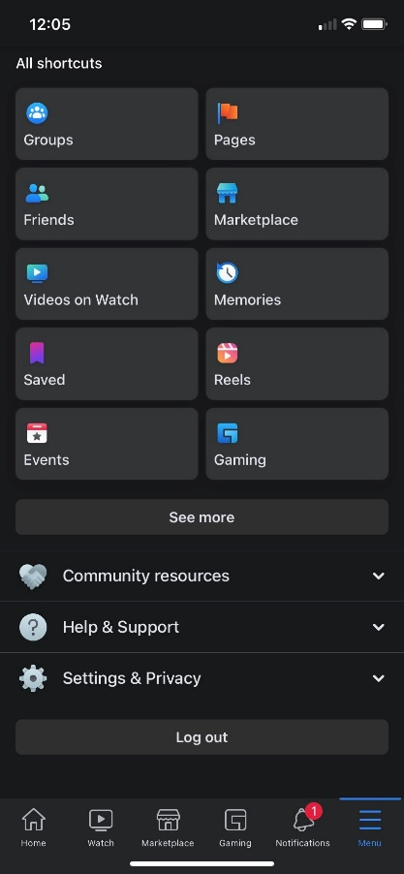

You will then start the process of creating a Facebook Page. Press Get Started.
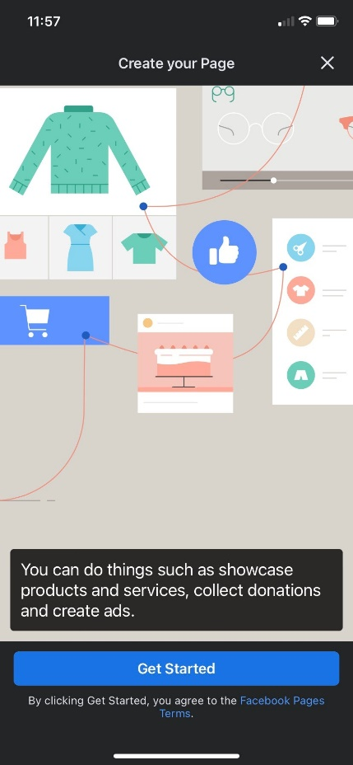

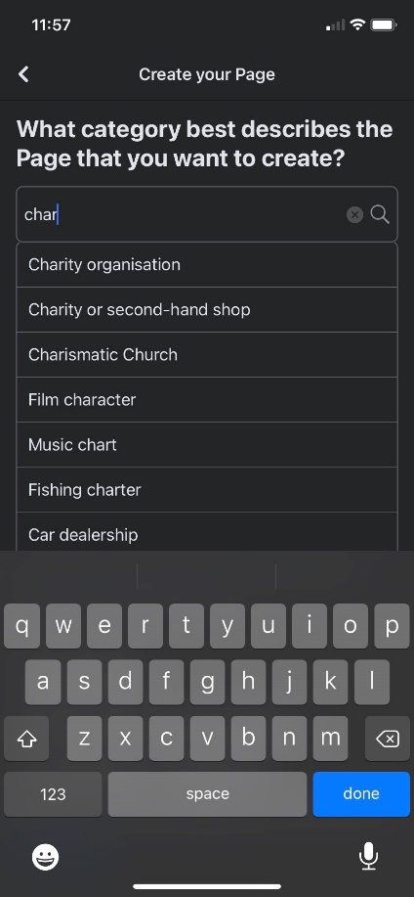
You will be asked what category best describes the Page you want to create. Start writing Charity, and you should see a drop down menu of ideas, select Charity Organisation, this should then be in a box. Press done on the keypad, you should then be able to press Next.
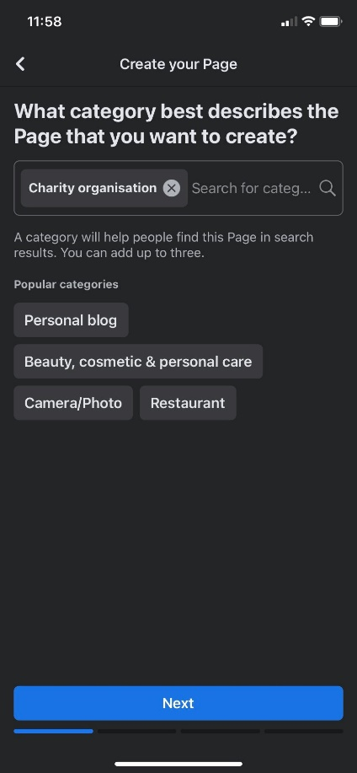
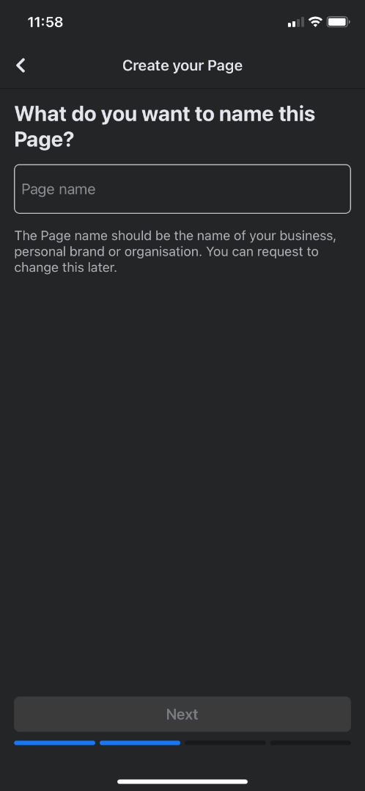
It will ask you what you want to name the Page, Enter your Pages Name, then press Next.

You can enter an address of where you meet or you can skip.
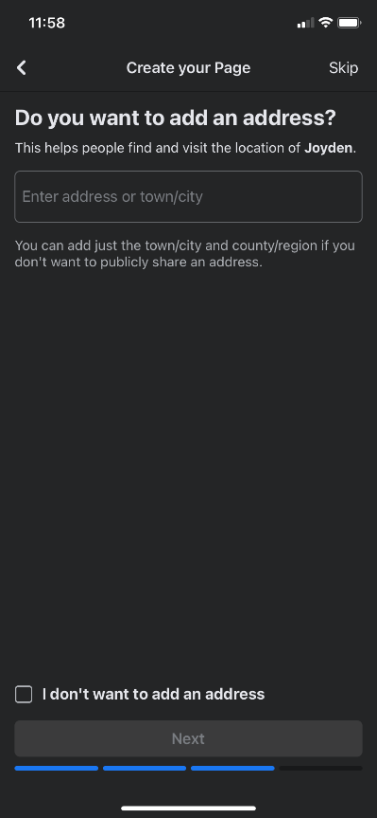

You can add a profile photo to your Page. If you add a photo, select Next. To complete this step later, select Skip.
You can add a cover photo to your Page. If you add a photo, select Next. To complete this step later, select Skip.
When you have completed the steps, select Next to go to your new Page.

