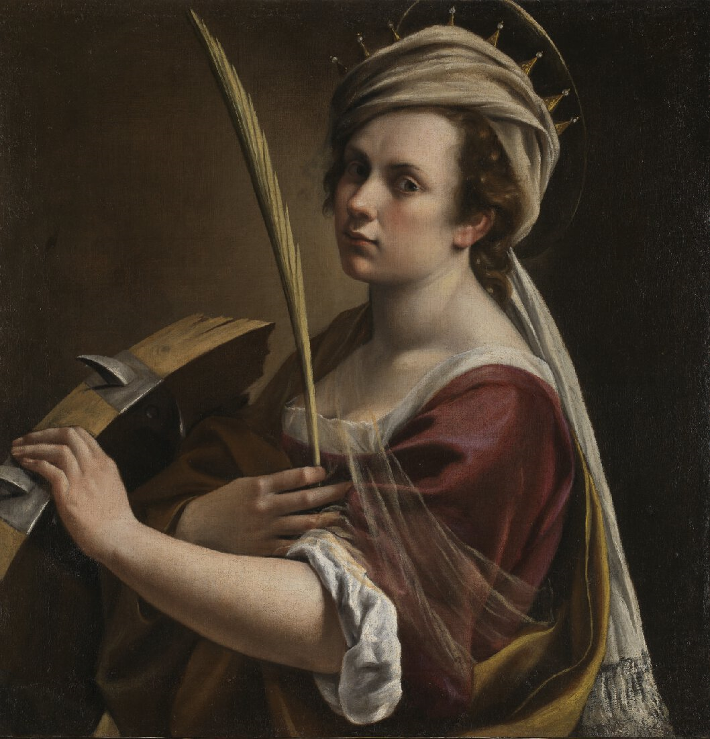Artemisia Gentileschi, Self Portrait as Saint Catherine of Alexandria, about 1615-17. @The National Galle

**Lady Denman Cup Competition 2021**

***“Let me show you what a woman can do!”***

**Schedule**

The NFWI is pleased to announce that the Lady Denman Cup Competition 2021 will be held in partnership with the National Gallery. Using no more than 500 words, WI members are invited to submit a piece of writing, fact or fiction, in any style (story, poem etc.) based on the above painting by Artemisia Gentileschi.

**Entries can be submitted either via email or by hard copy.**

Entrants must submit 4 copies of their entry, typed if possible, on A4 paper to theirFederation Secretary (some federations may accept entries via email, please check before sending) no later than **Friday 30th July 2021**. Any entries sent directly to the NFWI without being approved by the federation, cannot be entered and will be returned to the entrant. Please check entry fee requirements directly with your federation office.

Federations must send three copies of each entry to the Activities Co-ordinator at an address that is TBC no later than **Friday 17th September 2021**. Please ensure the name of the entrant, WI and federation are only written on the first copy; entrant’s details must not be written on the remaining copies.

Entries must be accompanied by a completed Individual Entry Form. A Federation Entry Form must be included with the final chosen entries for judging at national level.

**Electronic Entries:** Federations may email their chosen entries for national judging to [e.harker@nfwi-unit.org.uk](mailto:e.harker@nfwi-unit.org.uk) by the closing date. Each entry must be accompanied by an electronically completed Individual Entry Form and Federation Entry Form.

Please note…

* **To allow a fair and standardised competition timescale across all WIs and federations, the NFWI has set a closing date of Friday 30th July 2021 for members to submit their entry to their federation office. After this date, federations have until Friday 17th September 2021 to select up to three entries to go forward for national judging.**
* Each entry must include a total word count; entries with over 500 words will not be accepted and will be returned to the Federation Secretary. It is the responsibility of the federation to ensure that all entries submitted have the correct word count.
* Federations are kindly asked to support the competition and ensure members are aware of the competition timeframe.
* All entries will be judged in the first instance at federation level and up to three entries from each federation can go forward to the national competition.
* Federations will be charged £10 (incl. VAT) per entry. **Please do not send your entry fee with your entries.** After the closing date, the NFWI Finance Department will invoice those federations who have entered, accordingly.
* All federation entries will be acknowledged via email to the Federation Secretary.
* Please ensure that the total number of individual entries received for judging by the federation is completed on the Federation Entry Form
* It is at the discretion of each federation as to whether they wish to set a fee for members to enter the competition at federation level. It is the responsibility of the federation to ensure members are made fully aware of their closing date, any terms and entry fees.
* All entries at national level will receive a critique by the Judge.
* Requests for late entries to receive a critique by the judges, outside of the competition, will not be granted.
* Deadline for federation entries is **Friday 17th September 2021**.
* All forms relating to the competition can be downloaded from My WI/Make, create & do.
* **Results will be announced by early December 2021.**

##### Prizes

Book tokens will be given as prizes: 1st prize, book tokens to the value of £75; 2nd prize book tokens to the value of £50 and 3rd prize book tokens to the value of £30. The winner/winning federation will be presented with the Lady Denman Cup.

*#ArtemisiaToo: Artist, Avenger, Assassin*

*Emma Rees*

*For the very first time, the National Gallery is giving audiences in the UK the opportunity to see a major exhibition of work by the seventeenth-century Italian artist Artemisia Gentileschi. The paintings are bold and often extremely violent in theme. What inspired Artemisia repeatedly to represent biblical stories of murder, rape, and brutality in innovative ways? In this illustrated talk, Professor Emma Rees reveals what lay behind Artemisia’s artistic fascination with the same subjects which preoccupied her male counterparts in the Caravaggist School, but which were given a unique perspective in her hands. She argues that the paintings vividly depicting revenge and female empowerment – from Judith of Bethulia beheading Nebuchadnezzar’s tyrannical general, Holofernes, to Jael’s murder of Sisera, commander of the Canaanite army – are no less than Artemisia’s provocative and unapologetic early modern expression of today’s #MeToo movement.*

**To find out more about the ‘N0 MORE violence against women’ campaign and how you can get involved, please visit www.thewi.org.uk/campaigns/key-and-current-campaigns/no-more-violence-against-women**

